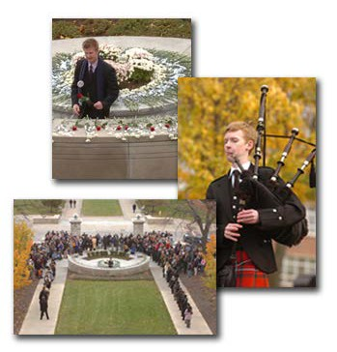The mission of the Remembrance Scholars is to educate the campus community about terrorism by relating Syracuse University’s Pam Am Flight 103 experience to more current events. Though education, we honor and remember all 270 lost in the bombing of Pan Am Flight 103, especially our 35 students.

Remembrance Week 2012:

Sunday, November 6 - Saturday, November 12

Friday, November 4

Cairn on the Quad
5:30 p.m. SU Quad
Building of the Cairn and Creating the Remembrance Ribbon display.
Scholars and SU Physical Plant staff will build the Memorial
Cairn on the Quad.

Sunday, November 6

Window Painting
11:00 a.m.
Schine Student Center, Ernie Davis Hall
Remembrance Pan Am 103

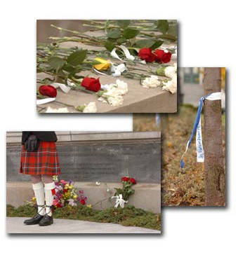Monday, November 7

Candlelight Vigil on the Quad
6:25p.m. SU Quad
The Remembrance Scholars invite all to a candlelight vigil on the Quad to honor and remember the 35 Syracuse University students who died aboard Pan Am Flight 103.

Tuesday, November 8

Open Mic for Hope and Remembrance
6:00 p.m.–7:30 p.m
Jabberwocky, Schine Student Center
An open mic / poetry reading in honor of the victims and with hope for a better future. Poets from Verbal Blend and Remembrance Scholars will be hosting the event.

Tuesday and Wednesday, November 8 and 9

Tabling
10:00 a.m. – 4:00 p.m.
Schine Student Center Atrium
Remembrance Scholars will distribute information, and answer questions, about Remembrance Week.

Wednesday, November 9

Panel Discussion : How Justice Has Changed Since Pan Am 103
7:30 p.m.
Maxwell Auditorium, Maxwell Hall

Thursday, November 10

Screening of Pan Am 103 videos/newscasts
7:00p.m.
Kittredge Auditorium, Huntington Beard Crouse Hall

Friday, November 11

Rose Laying Ceremony
2:03 p.m.
Wall of Remembrance, Hall of Languages

Remembrance Convocation
3:30 p.m.
Main Chapel, Hendricks

Reception
following the Convocation
220 Eggers Hall

Friday, November 11

A Moment of Silence
Carrier Dome
A moment of silence for the Pan Am 103 victims will be offered prior to the start of the SU vs. University of Southern Florida football game.

Marching Band Tribute
Carrier Dome
An announcement by Jack Jones, Announcer, Syracuse
University Marching Band, regarding Remembrance Week.
Band members, to honor the occasion, will be wearing black arm bands.

Saturday, November 12

Brunch
11:00 a.m. – 1:00 p.m.
Noble Room, Hendricks Chapel
Alumni brunch for Remembrance Scholars, the Remembrance
Scholar Alumni, and the London ’88 Alums.

Thursday, November 10 and Saturday, November 12

Victims of Pan Am Flight 103 meetings
Thursday, 7:00 p.m. – 9:30 p.m. Peter Graham Room, Bird Library Executive Board Meeting.

Saturday, 9:30 a.m. – 3:00 p.m. (tentative) Katzer Room, 327 Hinds Hall
Victims of Pam Am 103 Annual meeting.

Other happenings . . .

Chalking the Quad weather permitting SU Quad

Tree Ribbons
Ribbons bearing the name of the 35 student victims will be tied to trees on campus

During Remembrance Week

Sketches
Schine Student Center atrium
Pencil and ink sketches will hang in the Schine Student Center atrium.

Through Friday, Dec. 9th

Posters
SU Campus
Posters of the 35 students killed on Pan Am 103 will be displayed around campus

Other events will be held through the academic year, including:

November 4th-December 21

Set in Stone: Constructing the Arlington Memorial Cairn
Noble Room, Hendricks Chapel
This exhibit presents the history of the Arlington Cemetery Memorial Cairn, built “In Remembrance of the Two Hundred and Seventy People Killed in the Terrorist Bombing of Pan American Airways Flight 103 over Lockerbie, Scotland”, and dedicated November 3, 1995. From the lobbying efforts that made it possible, to the designs that made it visible, follow the story of the Cairn as shown by the Pan Am Flight 103/Lockerbie Air Disaster Archives at Syracuse University.

April 2012 – TBA

The “I Remember” 5K Walk and Race will be held on SU’s main campus.

Remembrance Week consists of a weeklong series of events honoring the lives of 35 Syracuse University students who lost their lives in the Pan Am Flight 103 terrorist attack over Lockerbie, Scotland, on December 21, 1988. Each year, 35
Remembrance Scholarships, each in the amount of $5,000, are awarded to undergraduate students for distinguished academic achievement, citizenship, and service to community. The
2011-2012 Remembrance Scholars will host all events.

Copyright © 2007 Remembrance Scholars at Syracuse University
304 Steele Hall, Syracuse, NY 13244- 1120
Phone: 315- 443- 1368 | Fax: 315- 443- 2198 | Email:remember@syr.edu Last modified on 10/15/09 | View our Privacy Policy

